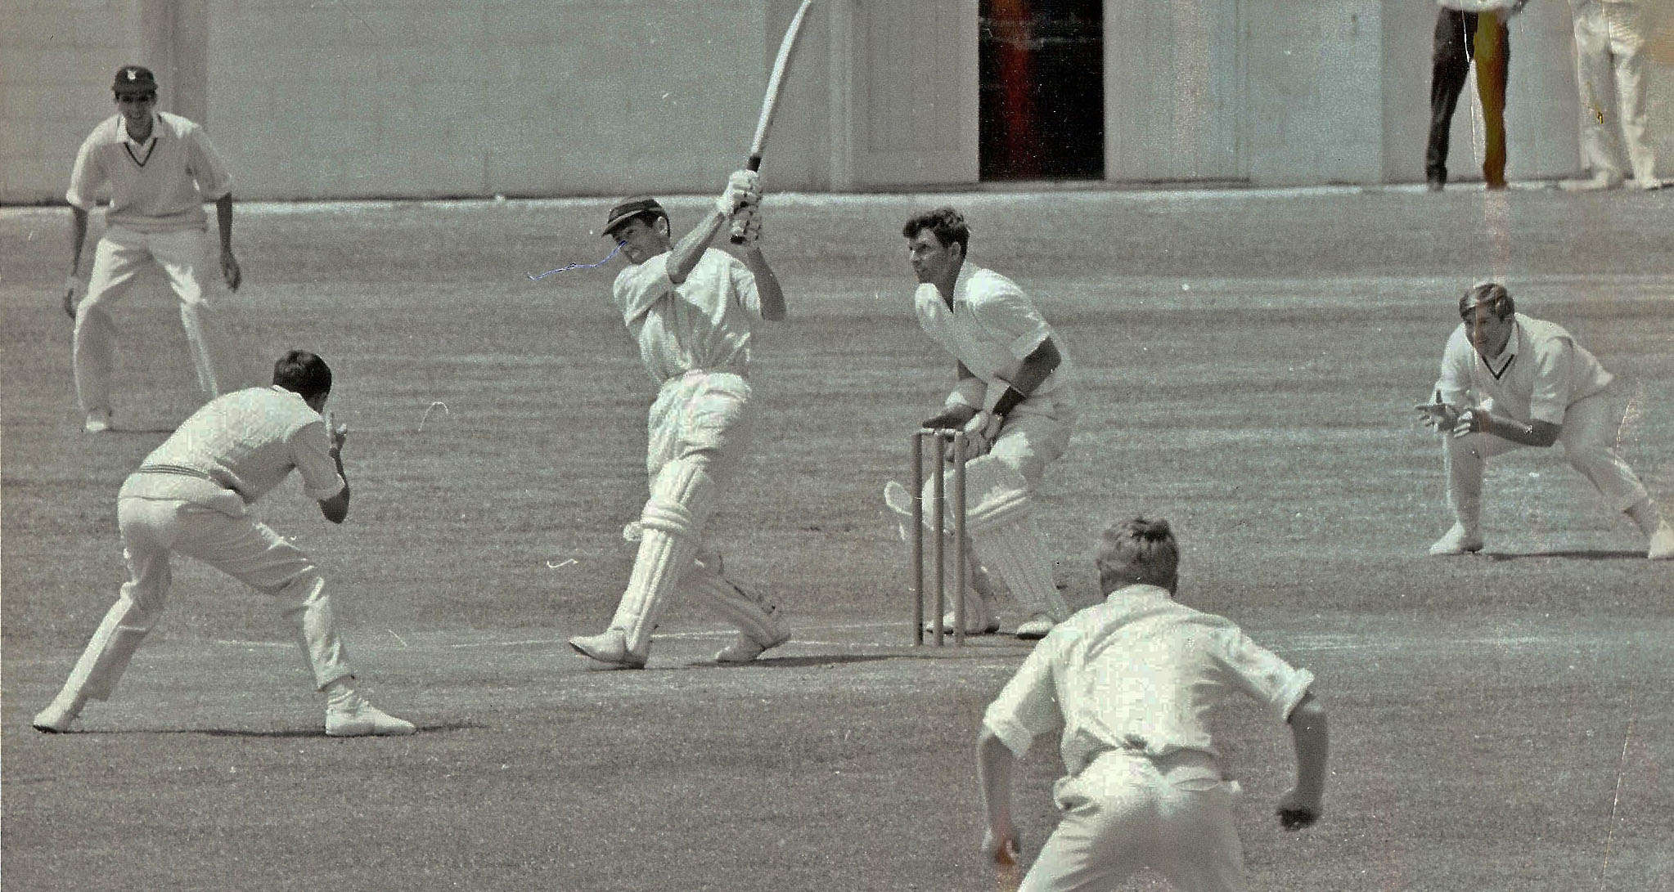

**GT Dowling hits a six against Central Districts at McLean Park Napier 15 January 1968. R Schofield wicket keeper, ML Ryan slip.**

**Dowling made 110 hitting 17 4’s and 2 6’s. Canterbury made 226 in reply to Central Districts 469/9 declared. The match was drawn.**